

14

13

12

10

9

8

7

2

1

3

11

English Page Path : /content/en/us/solutions/collaboration/index

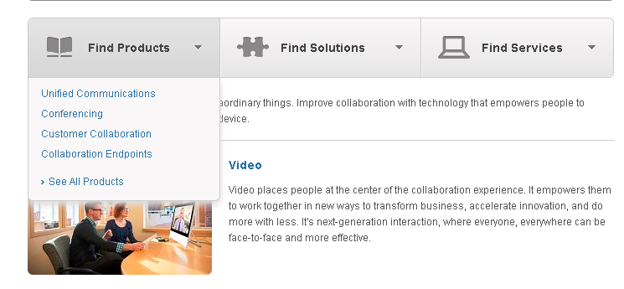

5

4

6

|  |  |  |  |
| --- | --- | --- | --- |
| 1 | /content/<locale>/solutions/<solution-category>/benefit/jcr:content/content_parsys/overview/layout-overview/gd12v2/gd12v2-left/hero_large*/title |  |  |
| 2 | /content/<locale>/solutions/<solution-category>/benefit/jcr:content/content_parsys/overview/layout-overview/gd12v2/gd12v2-left/hero_large*/description |  |  |
| 3 | /content/<locale>/solutions/<solution-category>/benefit/jcr:content/content_parsys/overview/layout-overview/gd12v2/gd12v2-left/hero_large*/linktext  /content/<locale>/solutions/<solution-category>/benefit/jcr:content/content_parsys/overview/layout-overview/gd12v2/gd12v2-left/hero_large*/linkurl |  |  |
| 4 | /content/<locale>/solutions/<solution-category>/benefit/jcr:content/content_parsys/overview/layout-overview/gd12v2/gd12v2-left/selectorbarlarge*/selectorbarpanel*/title |  |  |
| 5 | /content/<locale>/solutions/<solution-category>/benefit/jcr:content/content_parsys/overview/layout-overview/gd12v2/gd12v2-left/ selectorbarlarge*/selectorbarpanel*/panelitems |  |  |
| 6 | /content/<locale>/solutions/<solution-category>/benefit/jcr:content/content_parsys/overview/layout-overview/gd12v2/gd12v2-left/ selectorbarlarge*/selectorbarpanel*/alllinktext  /content/<locale>/solutions/<solution-category>/benefit/jcr:content/content_parsys/overview/layout-overview/gd12v2/gd12v2-left/ selectorbarlarge*/selectorbarpanel*/alllinkurl |  |  |
| 7 | /content/<locale>/solutions/<solution-category>/benefit/jcr:content/content_parsys/overview/layout-overview/gd12v2/gd12v2-left/text/text |  |  |
| 8 | /content/<locale>/solutions/<solution-category>/benefit/jcr:content/content_parsys/overview/layout-overview/gd12v2/gd12v2-left/spotlight_large_v2*/title  /content/<locale>/solutions/<solution-category>/benefit/jcr:content/content_parsys/overview/layout-overview/gd12v2/gd12v2-left/spotlight_large_v2*/titlelink/url |  |  |
| 9 | /content/<locale>/solutions/<solution-category>/benefit/jcr:content/content_parsys/overview/layout-overview/gd12v2/gd12v2-left/ spotlight_large_v2*/description |  |  |
| 10 | /content/<locale>/solutions/<solution-category>/benefit/jcr:content/content_parsys/overview/layout-overview/gd12v2/gd12v2-right/list*/title |  |  |
| 11 | /content/<locale>/solutions/<solution-category>/benefit/jcr:content/content_parsys/overview/layout-overview/gd12v2/gd12v2-right/list*/intro/paragraph_rte |  |  |
| 12 | /content/<locale>/solutions/<solution-category>/benefit/jcr:content/content_parsys/overview/layout-overview/gd12v2/gd12v2-right/list*/element_list*/listitems |  |  |
| 13 | /content/<locale>/solutions/<solution-category>/benefit/jcr:content/content_parsys/overview/layout-overview/gd12v2/gd12v2-right/followus/title |  |  |
| 14 | /content/<locale>/solutions/<solution-category>/benefit/jcr:content/content_parsys/overview/layout-overview/gd12v2/gd12v2-right/followus/links |  |  |